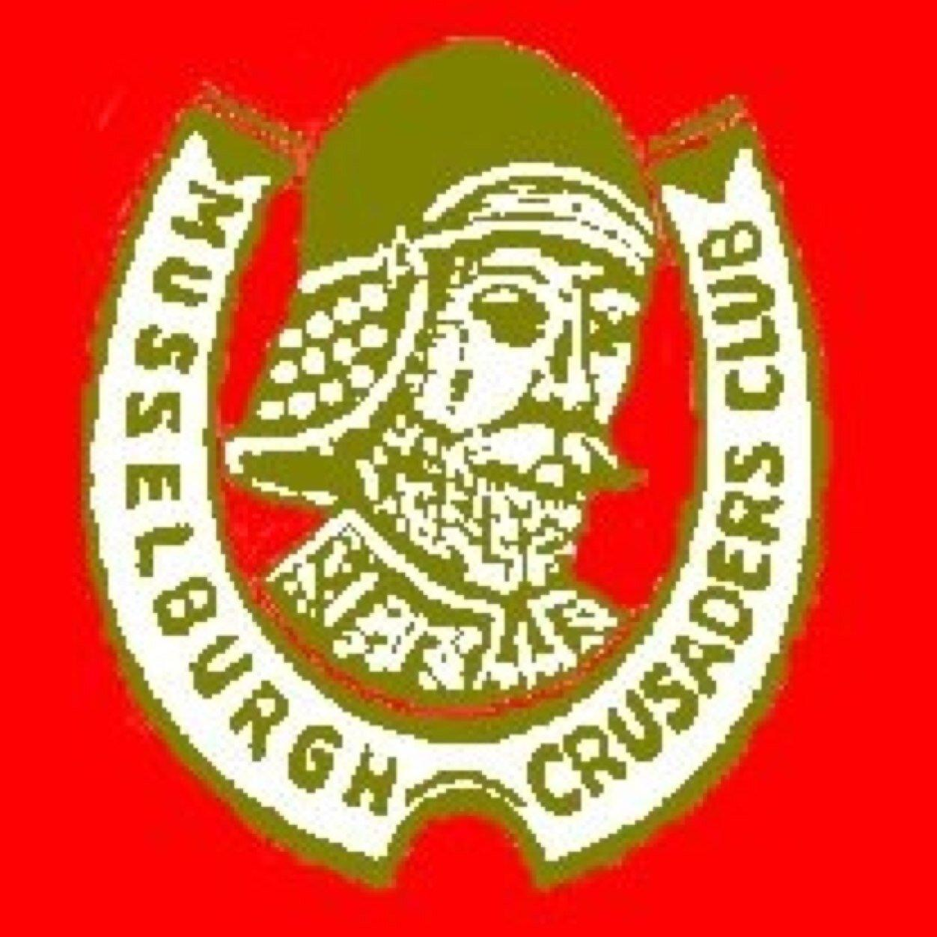
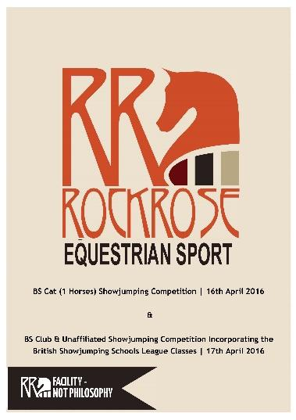
Musselburgh Crusaders Riding Club
Unaffiliated Open Show Jumping Show
Rockrose Equestrian Sport Centre
SUNDAY 9 April 2017 – Start 11.00 am
Rosettes: 1st to 6^{th in} each class
Entry Fees: All classes £10.00; Entry on day £12.00 (Except Class 1 which will be £5.00 per round)
First Aid: £2.00 per rider
By kind permission of James and Sonya Cunningham
All classes (except Class 1) run using table A7 and open to horses and ponies
Class 1: CLEAR ROUND Start Height up to 30 cm open
This class is also eligible for lead rein ponies and horses. All clear rounds will get a rosette.
Class 2: Start Height up to 30 cm open (lead rein welcome) - Prizes split between horses and ponies and those on and off lead rein.
This class kindly sponsored by Neil Wilson of Wilson’s of Musselburgh Fruit Shop and Town Champion of the 2016 Riding of the Marches.
Class 3: Start Height up to 50 cm open - Prizes split between horses and ponies.
This class kindly sponsored by Graham Bennett Joiners Musselburgh – no job too big or small.
Class 4: Start Height up to 60 cm open – Prizes split between horses and ponies.
This class kindly sponsored by Jill Smyllie Hairdressing, Musselburgh
Class 5: Start Height up to 70 cm open – Prizes to both horses and ponies.
This class kindly sponsored by Ali Barclay, the Sandwich Stop, Musselburgh
Class 6: Start Height up to 80 cm open – Prizes to both horses and ponies.
This class kindly sponsored by Kieran Davidson and Mhairi Braby, Honest Lad and Lass Musselburgh 2015.
Class 7: Start Height up to 90 cm open – Prizes to both horses and ponies.
This class kindly sponsored by Margaret Ross, President of the Musselburgh Crusaders Riding Club.

Refreshments, Light Snacks and Home Baking available on the day.
Closing date for entries – Wednesday 5th April 2017
Enquires to musselburghcrusaders@gmail.com or contact Scott Nisbet 07842 905607 / Margaret Ross 07918683186

Rockrose Equestrian Sport Centre, Sunnyside Farm, Haddington, East Lothian EH41 4PZ

- The organisers & landowners do not accept any liability for damage, accident, injury or illness to horses, riders, spectators or personal property.
- No entries will be accepted without payment.
- Payment must be made via bank transfer or by post with a cheque, details as below.
- All horses to be 4yrs & over.
- Dogs must be kept on a secure lead at all times.
- A hard hat to EN1384, PAS015, prefixed ASTMor SEI must be worn & fastened at all times while mounted. American standard SNELL E2001 SNZ 3838 (Australasia) also permitted. Any rider found to be using a hat to a lower specification will be disqualified.
- Entry fees are only refunded if the event is cancelled. There are no refunds for call offs once the closing date passed.
- Cantering is only permitted in practice & competition areas
- The Judge’s decision is final Objections must be made in writing to the show secretary within 30 mins of any incident along with a deposit of £50. This will only be refunded where the objection is upheld.
- Practice fences will be flagged & must be jumped in the correct direction.
- Please be courteous & ensure you leave the venue as you find it including parking areas.

CLASS | Age (if under 16) | RIDER | HORSE |  | Horse/Pony | FEE
£10 PER CLASS (pre entry)  £12 PER CLASS (entry on day) |  |  |  | FIRST AID COVER (£2.00)
 |  |  |  | TOTAL

Name................................................................................................................... Tel No: …………………………………...………………….

Address [required]................................................................................................................................................…………..…….....

Signature.............................................. ……………………………….. (REQUIRED – If under 16yrs must be signed by Parent or Guardian)

E-mail Address ..........................................…………………………… Emergency Contact Tel No: ……………………………….................
Entries as follows-
Bank Transfer:
Musselburgh Crusaders Riding Club, Sort code 83-25-43, Account number 00200304 (please quote your name)
Cheque:
Made payable to - Musselburgh Crusaders Riding Club, C/o Margaret Ross, 4 Windsor Park Terrace, Musselburgh, East Lothian, EH21 7QN

